Collins Legacies: The 30W Transmitter

By J.B. Jenkins, W5EU and Gary Halverson, WA9MZU

Today, many folks don't know that over a dozen amateur transmitter models were produced in the first ten years of Collins Radio, beginning in 1932. While few of these transmitters have survived today, it was these products that established the Collins reputation for quality, performance, and reliability.

This column will introduce you to a "new" pre-war Collins transmitter with each upcoming issue of The Signal.

"The smoothest, neatest little rig you ever saw"

Before getting into the first transmitter, it's interesting to see how it all started. Arthur Collins’ first ad in QST magazine appeared in January of 1932. The ad offered "a radically new design" crystal-controlled transmitter kit less tubes, crystal and power supply. When you consider that the average ham then was hay-wiring transmitters on breadboards from QST articles, a polished aluminum chassis with hard rubber panel transmitter kit was indeed "radical".
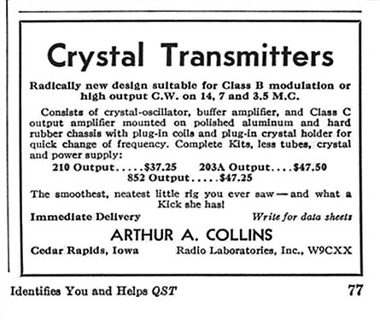
Note the name as Radio Laboratories, Inc., W9CXX. The use of “Inc.” is curious as it wasn’t until the following year the company incorporated under Delaware law.

Arthur Collins’ second ad in QST magazine appeared three months later in March of 1932. It too promoted Collins Crystal Transmitters (with carrier powers from 30 to 300 watts), but also mentioned "a complete line of power supplies, modulator and input equipment, relay racks, quartz crystals, etc.” And the company name is now Collins Radio Transmitters.

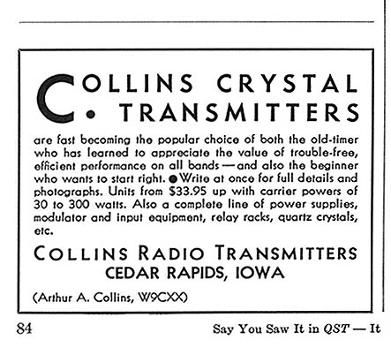

Collins Radio Transmitters ads continued through April, May, June, July, September, and October of 1932. The ads quickly grew more sophisticated with the model 150 appearing in the first ad containing a photograph.

In November of 1932, the first full-page ad appeared on page 73 of QST and featured Collins audio and power transformers. At the bottom of the page appears Collins Radio Company with an explanation that “Collins Radio Transmitters is now known as Collins Radio Co., in order to include its widened field of activity”.

Reading between the lines, it's apparent that Collins Radio was growing rapidly, and not only had designs in hand for a number of complete phone and cw transmitters, but also had established relationships with key component suppliers.

The 30W

While the model 150 was the first product photograph to appear in a Collins ad, its exciter offered a far greater sales potential.

The 30W was the very first assembled and tested Collins transmitter offered to the general amateur community, and was introduced in mid 1932. Based on modular building blocks, the 30W consisted of a 500AX power supply and a 10A RF chassis (the Crystal Transmitter kit originally offered) mounted in a sheet metal frame. An optional tuner unit was also offered. Each unit had a bakelite front panel attaching to a polished aluminum or steel chassis. Although primitive in comparison to later Collins products, the hallmarks of Collins transmitter philosophy were established in its design.

The 30W’s black bakelite panels were crisp and clean with a layout emphasizing convenience. Controls were clearly identified with engraved captions. Its most impressive feature was the row of four Weston model 310 “bug-eye” surface mounted meters adorning the power supply front panel. Above it, a plug-in crystal socket was located on the 10A front panel.

The 10A Crystal Control unit used a 247 crystal oscillator, a 247 buffer amp, and a 210 output. Three plug-in coils wound on bakelite coil forms were used in the oscillator, buffer, and output circuits. A fixed-turn magnetic coupling winding on the output coil was terminated to either the optional antenna coupling unit, or to two white porcelain cone insulators mounted on the rear brace that spanned the top of the frame.

The 30W was also one of the basic building blocks of the 40A/B, and the 150A/B transmitters. According to the 30W bulletin, it could be converted into one of these larger transmitters merely by adding other units and it was not necessary to discard any of the original equipment.

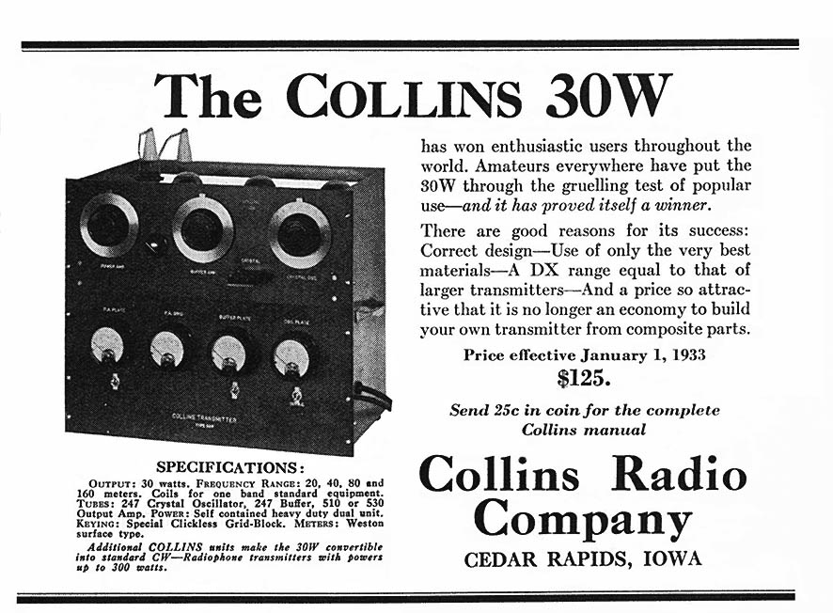

In July of 1932, the 30W was introduced at a price of $95.60, however, by January of 1933 the price had risen to $125.00.

The 30W was a big success as mentioned one year later in the April - August 1933 Signal.

"A few people have gained the impression that the 30W transmitter was discontinued with the announcement of the 32A and 32B transmitters. This is most decidedly not the case. There are more 30W transmitters in operation than any other COLLINS type and the sales of the 30W are
continuing to keep pace with sales of the 32A and the 32B. The 30W has slightly greater output than the 32A and is ideal for the amateur who is
primarily interested in cw work or who plans to convert his 30W to a 150A or 150B at a later date."

Also mentioned in the Signal:

"Mr. M.R. Cooper, W7FO, reports that the first three stations worked with his 30W were W9FJQ, VK5HG, and ZL3CC in the order named. Australia and New Zealand reported QSA5R5."

"Mr. Benton White, W4PL, reports that he is working K6's (Hawaii) regularly on both 40 and 80 meters with his 30W and that he is beginning to make contacts with VK stations."

"K6AJA is putting consistent signals into the states" with his 30W."

So what happened to the Crystal Transmitter kits? Our guess is that since labor was cheap in 1932, by assembling completed and tested units Collins could assure the quality of its products. No so with kits. This may have been the reason the kits were only advertised a few months. (No kits have ever surfaced since then.)

For a great story about one of the first sales of a 30W (to Benton White, W4PL), see "A tale of an early sale" by Ed Marriner in August 1965 CQ, (reprinted with permission on page 12 in "The First 50 Years".

Next issue: The Model 150 Transmitter.

